Ref. No. / Civil/Env/ Date : 4/04/2022
AQ Monitoring Report
Name of Work: Ambient Air Quality Monitoring at Sawalwadi Village ; Taluka Miraj, Dist: Sangli
Background: As per the letter No. 38/2021-22, received from Sarpanch ; Grampanchayat Sawalwadi had requested the institute to give air quality report in order to meet with one of the requirements for their participation in “Majhi Vasundhara Abhiyan”, an activity launched by Government of India for the betterment of environment for the local bodies in Maharshtra. In response to the same the site under consideration was visited on 01/04/2022 and ambient air quality monitoring was done as per the Central Pollution Control Board norms. An air quality monitoring was done by using RDS (New Improved Respirable Dust Sampler Mod. No. APM 460 NL and Gaseous Pollutants Sampler Mod. No. APM 433 make Envirotech Instruments , New Delhi ) The gaseous pollutants were monitored for 4 hours during 11 am to 3 pm and 3 pm to 7 pm. The particulates were measured during 11 am to 7 pm for eight hours as per standard procedures. The results based on actual monitoring work for the AQ parameters are as follows,

Sr. No. | Air Quality  Parameter | Unit | Concentration |  | Analysis Method
 |  |  | Observed | NAAQS*
1 | RSPM < PM 10 | μg/m3 | 97 | 100 | Gravimetric Method
2 | SO₂ | μg/m3 | 4 | 80 | Improved West and Gaeke Method
3 | NO_{x} | μg/m3 | 27 | 80 | Jacob & Hochheiser modified  (NaOH-NaAsO2) Method
* NAAQS: NATIONAL AMBIENT AIR QUALITY STANDARDS (2009) for Industrial, Residential, Rural and other Areas.

Monitored by: Mr. V. B. Bhokare & Mr. S. S. Gabbur Analyzed by: Mrs. S. R. Pinjari
NOTE: The institute has received Rs. 7000 + 18% GST. Vide BoI netbanking transaction ID 2914844891 & 2914845720 No. dated 4/04/2022

Findings:
The site under consideration is situated at Sawalwadi (16.8658° N, 74.4203° E). The population of the village is 1818 (Census 2011). The major occupation is agriculture based and the place is not characterized by industrial and vehicular pollution. Based on actual monitoring work the Air Quality can be expressed as not polluted.

Dr. P.G. Sonavane  Professor & Deputy Director,  WCE, Sangli | Dr. G.R.Munavalli  Faculty In-charge Environmental Engg Lab | HoD (Civil)
Photographs of Monitoring Site:
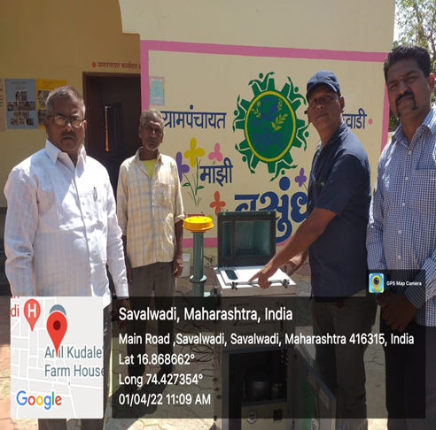 | 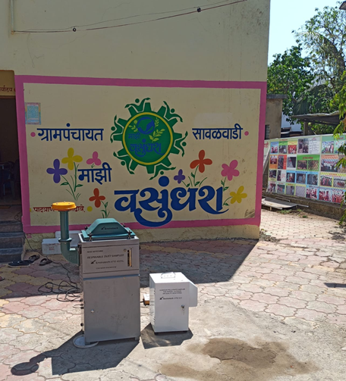 | 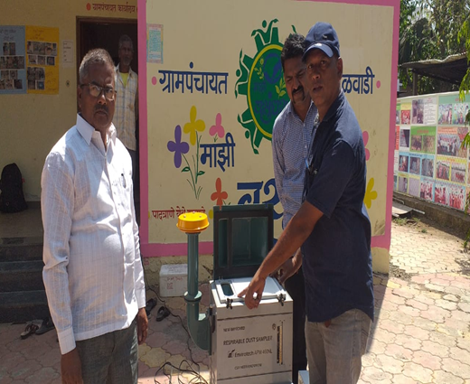
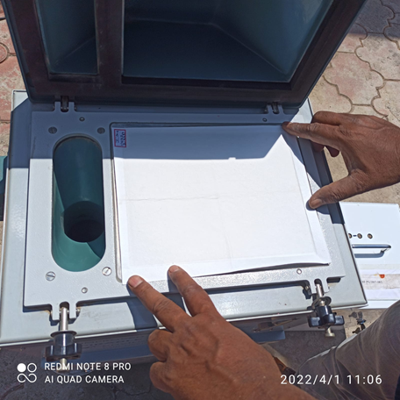 | 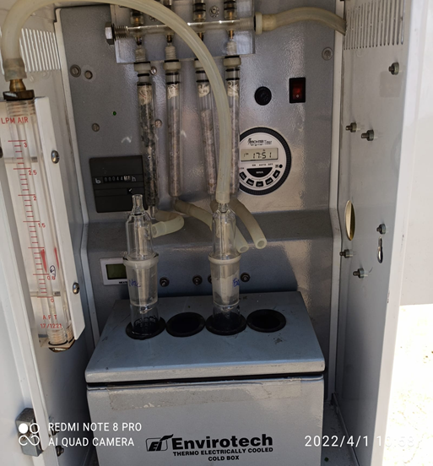 | 